|  |
| --- |
|  |
| **Masterplan and Feasibility Study for West Hendon Playing Fields - Addendum Report**  **Barnet Council**  January 20 |
|  |





**Contents**

1 introduction 2

1.1 Background 2

1.2 The Structure of our Report 2

2 summary OF public CONSULTATIOn 3

2.1 Introduction 3

2.2 Stakeholder Engagement 3

2.3 Wider Public Engagement 4

2.4 Summary 5

3 amendments to masterplan following public consultation 6

3.1 Introduction 6

3.2 Meeting with Barnet Council 6

3.3 Further Stakeholder Engagement 6

3.4 Consultation with Planning / Highways 8

3.5 Masterplan Amendments 8

3.6 Business Case Amendments 11

4 conclusions 12

5 APPENDIX 1: West Hendon Playing Fields Masterplan consultation report 13

6 appendix 2: final draft masterplan 14

introduction

Background

The Sport, Leisure and Culture Consultancy (SLC) was commissioned by Barnet Council in March 2018 to develop a masterplan and feasibility study for the development of a strategic sports hub with a wider leisure and community offer at West Hendon Playing Fields.

The study was completed in February 2019 and the outputs provided to the Council through a report entitled Masterplan and Feasibility Study for West Hendon Playing Fields and Associated Community Facilities.

The final draft masterplan was reviewed by the Council’s Environment Committee in March 2019 and approval given to undertake full public consultation on the masterplan. SLC was subsequently commissioned to support this process, collate the results and consider, through discussion with the Council’s Project Team, any required amendments to the masterplan arising from the public consultation.

This report provides an overview of this latest stage of the project and forms an Addendum to the main Masterplan and Feasibility Study report and should therefore be reviewed in conjunction with the main report.

The Structure of our Report

This report is structured to meet the requirements of the Council’s brief and to provide an accessible report setting out our core findings and key outputs.

Table 1: Report Structure

|  |  |  |
| --- | --- | --- |
| Section | | Key Content or Output |
| 2 | Summary of Public Consultation | Summary of feedback from consultation with key stakeholders and the general public. |
| 3 | Amendments to Masterplan Following Public Consultation | An overview of the amendments made to the final draft masterplan following the public consultation feedback. |
| 4 | Conclusions | Key conclusions arising from the consultation exercise. |

Supporting information is included in a series of Appendices.

summary OF public CONSULTATIOn

Introduction

In Summer 2019, SLC supported the Council in undertaking a comprehensive public consultation on the final draft masterplan for West Hendon Playing Fields. This was delivered through a combination of face-to-face meetings, email correspondence, telephone discussions, workshops, public drop-in sessions and an online questionnaire with key stakeholders and the general public.

The consultation process engaged with over 900 local residents and stakeholders during the 8-week period which demonstrates a good level of engagement.

A copy of SLC’s full report on the public consultation is provided in Appendix 1 and a summary of the key points and conclusions provided below.

Stakeholder Engagement

Key stakeholders were invited to provide feedback on the final draft masterplan, including current users / existing occupiers, local sports clubs, under-represented groups, local schools, environmental statutory bodies and conservation groups.

A summary of feedback is provided below:

* SLC attended a meeting of the **West Hendon Partnership Board Resident Group**, who welcomed the proposed new facilities to the playing fields, particularly to encourage young people to be more active. Residents were keen to ensure the facilities are affordable and were pleased to see a wide range of free-to-access activities.
* Barnet Council attended a meeting with the **Welsh Harp Joint Consultative Committee (WHJCC)**, who strongly opposed the Cool Oak Lane car park and high ropes course on the basis of a loss of greenspace, potential anti-social behaviour and inappropriate road access. A petition of 328 signatures objecting to the car park and coach drop-off demonstrated residents’ concerns.
* SLC facilitated a workshop with pupils (aged 11-15) from **Hendon School**, the majority of whom rarely visited the park due to a lack of facilities. Positive feedback was received on the proposals, the most popular facilities being the outdoor gym / trim trail, improved football pitches and tennis courts.
* A telephone conference and formal written feedback was received from **Natural England**, who were broadly supportive of the masterplan and the value it would provide to local communities, as well as bringing people closer to nature and biodiversity. Concerns raised in relation to the Site of Special Scientific Interest (SSSI) should be possible to mitigate against through design interventions such as additional vegetation, directional lighting and permeable car parking surfaces.
* A telephone consultation and formal written feedback was also received from the **London Wildlife Trust** (LWT), who, whilst support the principle of improved recreation facilities, noted that not enough consideration has been given to the impact upon the SSSI and Local Nature Reserve (LNR). Specific concerns of the LWT related to the impact of the floodlit artificial turf pitches, high ropes course and proposed Cool Oak Lane car park.
* Further feedback was received from the **Canal and River Trust**, **Royal Society for the Protection of Birds (RSPB)** and **Welsh Harp Conservation Group**. The key concern raised by these groups was the potential impact of the proposals upon the biodiversity of the SSSI and LNR. The artificial turf pitches, size of the Community Sports Hub, path network, high ropes course and Cool Oak Lane car park were the facilities causing particular concern.
* Email correspondence and a formal letter was received from **Armstrong Rigg Planning (ARP)** who, on behalf of their client Taylor Wimpey, are involved in the potential redevelopment of Woodfield Nursery into replacement business premises and new housing. A full planning application is yet to be submitted, however ARP wished to note their support for the masterplan and the enhancement it would bring to the local area.

Wider Public Engagement

Local residents and wider general public were invited to provide feedback on the final draft masterplan through an online questionnaire, public drop-in sessions, email correspondence and social media.

The online questionnaire received 224 responses, 35% of which were from young people (under 25). 72% of respondents were supportive of the final draft masterplan (52% very supportive, 20% tend to support), whilst 21% were unsupportive (16% strongly oppose, 5% tend to oppose). The Council’s Facebook page on the masterplan received 133 ‘likes’.

73% of respondents noted that they would be more likely to visit West Hendon Playing Fields if the masterplan was delivered and 70% said they would be more likely to be physically active.

The most popular ranked facilities were as follows:

* Improved pedestrian routes and links to Welsh Harp (84% support)
* Improved grass pitches (82% support)
* Café and toilets (80% support)
* Improved cycle routes (76% support)
* Woodland nature trail (75% support).

Over 70% of respondents were also supportive of the multi-use activity space, picnic areas, community garden, enhanced toddler play area, tennis courts, adventure play area and outdoor gym / trim trail.

The most strongly opposed facilities were the skatepark (29% unsupportive) and high ropes course (28% unsupportive). The open comment boxes also highlighted key areas of concern as being the Cool Oak Lane car park, anti-social behaviour and protection of greenspace and wildlife.

A total of five public drop-in sessions were held at prominent public locations close to and in West Hendon Playing Fields. These sessions were publicised to local residents through posters displayed in the playing fields and flyers which were distributed to neighbouring properties. The sessions provided an opportunity for local residents to view the masterplan up close, ask questions and provide feedback. The key themes arising from these sessions are listed below:

* Concerns regarding the proposed Cool Oak Lane car park and general traffic and congestion in the area due to an increased number of visitors.
* Concerns regarding the impact of the high ropes course on woodland and biodiversity.
* Positive feedback received on improved pedestrian and cycle routes, tennis courts, multi-use games area (MUGA), new play areas, adventure golf, café, outdoor gym and community garden.
* The success of the development will largely depend on future management arrangements, security presence and levels of maintenance.

Summary

Overall, the consultation demonstrated clear support amongst users, stakeholders and the wider public for the principle of creating a more engaging space at West Hendon Playing Fields, which improves opportunities for local people to be physically active and increases use of the playing fields and exposure to the Welsh Harp and SSSI.

The key areas of contention raised through the consultation include:

* The proposed car park on Cool Oak Lane
* The proposed location of high ropes
* Artificial turf pitches and impact upon open space / biodiversity
* The impact of proposed facilities on the SSSI/LNR
* The impact upon traffic and congestion.

amendments to masterplan following public consultation

Introduction

This section describes the steps undertaken by SLC and the Council in response to the public consultation and in addressing key areas of contention.

Meeting with Barnet Council

A meeting with Barnet Council’s Project Team was held on 5th September 2019 to discuss the results of the public consultation and to decide on any potential amendments to the final draft masterplan.

In response to the strong objections to the location of the proposed Cool Oak Lane car park and the high ropes course, it was agreed to explore the feasibility of relocating these facilities. Woodfield Park (immediately south of Cool Oak Lane) is owned by the Council and was discussed as a potential alternative location, with links to existing users, Princes Park Football Club and Phoenix Canoe Club.

There is an existing area of rough ground in the north of Woodfield Park which is used informally for parking. It was agreed that this area provides an opportunity to extend and establish permanent parking as an alternative to the proposed car park on Cool Oak Lane. This would also allow the existing grass football pitch to be retained in the area currently identified for this car park.

A re-configuration of the football pitches on Woodfield Park could also provide space for the high ropes course in the south-east corner.

To explore these options further, it was agreed that SLC should consult with Princes Park Football Club, Phoenix Canoe Club and Armstrong Rigg Planning.

Despite objections to the artificial turf pitches, it was agreed to retain the proposed ATPs in their current location. A clear need for ATPs in the area has been evidenced in the Council’s Playing Pitch Strategy and their existing position is considered to be optimal in terms of planning risk and impact upon the SSSI, and also allows for potential links with the adjacent Hendon Football Club. Consideration was given to relocating one of the ATPs further north, however this may result in increased disturbance to residents and potential bat roosts. Instead, it was agreed to include additional planting along the boundary of the LNR to act as a ‘buffer zone’ between the ATPs and the areas of ecological interest.

In response to concerns raised by environmental statutory bodies and conservation groups, it was agreed to simplify the pedestrian and cycle routes within the SSSI to one path, provide additional planting and landscaping throughout the masterplan and relocate one of the grass 11 v 11 football pitches to the Cool Oak Lane car park site (which was previously located adjacent to the LNR). These planting and landscaping enhancements would be beneficial in terms of increased biodiversity and would help protect the SSSI/LNR.

Further Stakeholder Engagement

SLC undertook further stakeholder engagement in October 2019 to explore the feasibility of utilising Woodfield Park as described above. Telephone consultations were held with the stakeholders listed in Table 1 and Southern Green Landscape Architects visited the area to undertake a high-level site analysis.

***Table 1: Consultation with Woodfield Park Stakeholders***

|  |  |
| --- | --- |
| **Name** | **Key Outcomes of Consultation** |
| **Phil Atkinson, Centre Development Director, Phoenix Canoe Club** | Phoenix Canoe Club were very supportive of the suggested proposals to improve and extend the existing car park in the north of Woodfield Park. This car park is in poor condition (unmarked, sloping, over-grown) and currently overflows, particularly during weekend football matches. Potential concern was raised with regard to pedestrian access to West Hendon Playing Fields, as there is no safe crossing along Cool Oak Lane.  The Club has plans to redevelop their facility (subject to raising considerable funding), which would include 12-16 car parking spaces, an outdoor climbing wall, low ropes course and café. They were supportive of the proposed relocation of the high ropes course and considered this as being highly complementary to their existing outdoor offer. |
| **Christian Leite, Football Development Manager, and Jon Bell, Volunteer and Retired Chairman, Princes Park Football Club** | Princes Park Football Club highlighted that car parking is a major problem for the club and results in overflow parking along Cool Oak Lane, Kinloch Drive and the edges of Woodfield Park. They have been in discussion with the Council to resolve this issue and are therefore in favour of exploring the opportunity of extending and formalising the existing car park (providing it is not to the detriment of the football pitches).  Similarly, the Club were supportive of a proposed high ropes course, providing they can maintain their current pitches and training areas. They agreed that Woodfield Park is currently under-utilised as a site and the area has great potential for development. The Club suggest that use could be made of the Club’s pavilion building to service the high ropes course, particularly as it is under-utilised during the daytime. |
| **Lynsey Rigg, Director, Armstrong Rigg Planning** | Lynsey Rigg, on behalf of Taylor Wimpey, explained that a final planning application for 37 residential units and replacement business facilities on Woodfield Nursery was due to be submitted by the end of 2019 (yet to be submitted at the time of this report). The main demographic for the new housing development is projected to be families (3-4 bedrooms), supplemented with affordable housing and 1-2 bed apartments.  The main access point would be via the north-east entrance and there are proposals to re-work the junction point. However, there are no current plans to carry out works on Cool Oak Lane or provide a pedestrian crossing point.  No concern was raised by Armstrong Rigg on the relocation of high ropes, providing the height did not impede on residential housing. An extension to the existing car park was viewed less favourably, as this would be at the frontage of the proposed houses and effect views across Woodfield Park. The rationale behind the car park extension, however, was understood. Therefore, if the car park is properly screened by fencing and planting, they do not envisage an issue with it. |

Consultation with Planning / Highways

High-level feedback on the final draft masterplan for West Hendon Playing Fields was provided by Barnet Council Planning Policy and Highways Officers at a meeting on 7th January 2020.

No significant issues were highlighted by the Planning Officer, but consideration should be given to potentially linking the community garden with the allotments, the availability of public transport and opportunities to enhance the ecological interest of the site.

Similarly, no significant issues were identified by the Highways Officer. The proposed relocation of the car park was considered to be a sensible alteration, although there may need to be improvements to the entrance to Woodfield Park. A crossing point should also be considered to allow safe access across Cool Oak Lane, possibly at the western end. Focus should be given to encouraging public transport use (to help mitigate the potential shortfall in car parking spaces) and linking to the new Barnet Loop. It would also be important not to leave the south-west area of the masterplan as ‘dead space’ but facilitate cycle and walking routes as per the masterplan. Widening Cool Oak Lane was not considered appropriate at this stage as this may potentially encourage further traffic. Although, it was suggested that there may be a requirement to widen the footpath along Cool Oak Lane if feasible. The impact of further traffic as a result of development would need to be explored in detail through a transport and parking assessment as part of any future planning application.

Masterplan Amendments

Following the outcomes of this further consultation, the Council agreed for the following amendments to be made to the final draft masterplan:

Relocation of car parking to Woodfield Park. The proposed car park would be 94 spaces compared to the 99 spaces provided in the Cool Oak Lane car park.

Relocation of the high ropes course to Woodfield Park.

Include a new pedestrian crossing point along Cool Oak Lane to provide safe access between West Hendon Playing Fields and Woodfield Park.

Simplified pedestrian / cycle route through SSSI and relocation of proposed bird hides.

Include increased planting to create a ‘buffer zone’ between the ATPs and LNR.

The Final Draft Masterplan is shown in Figure 1 and a full, high resolution version is provided in Appendix 2. A detailed area plan of Woodfield Park showing the relocated car park and high ropes course is shown in Figure 2.

Figure 1: Final Draft Masterplan with Agreed Amendments

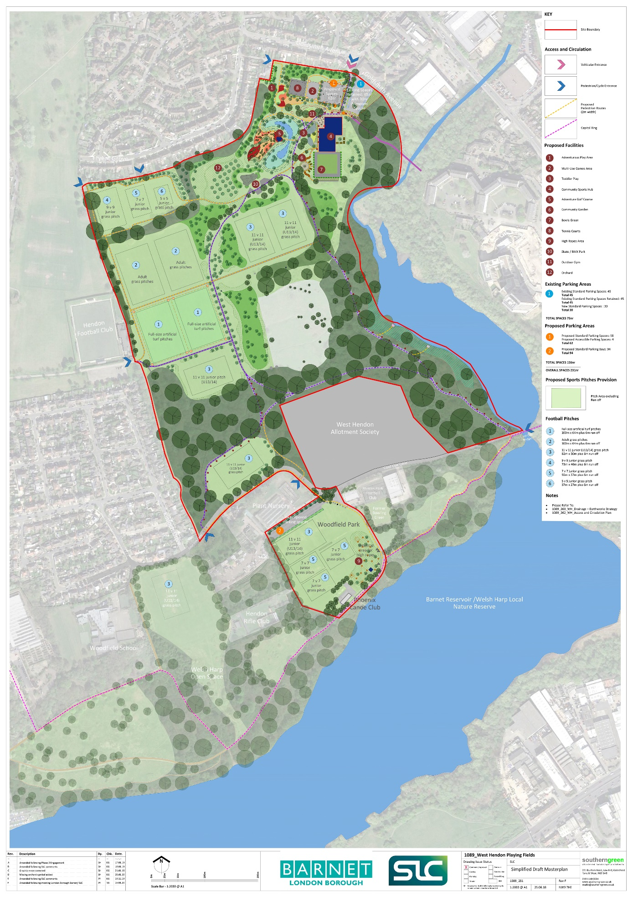

Figure 2: Detailed Area Plan – Woodfield Park

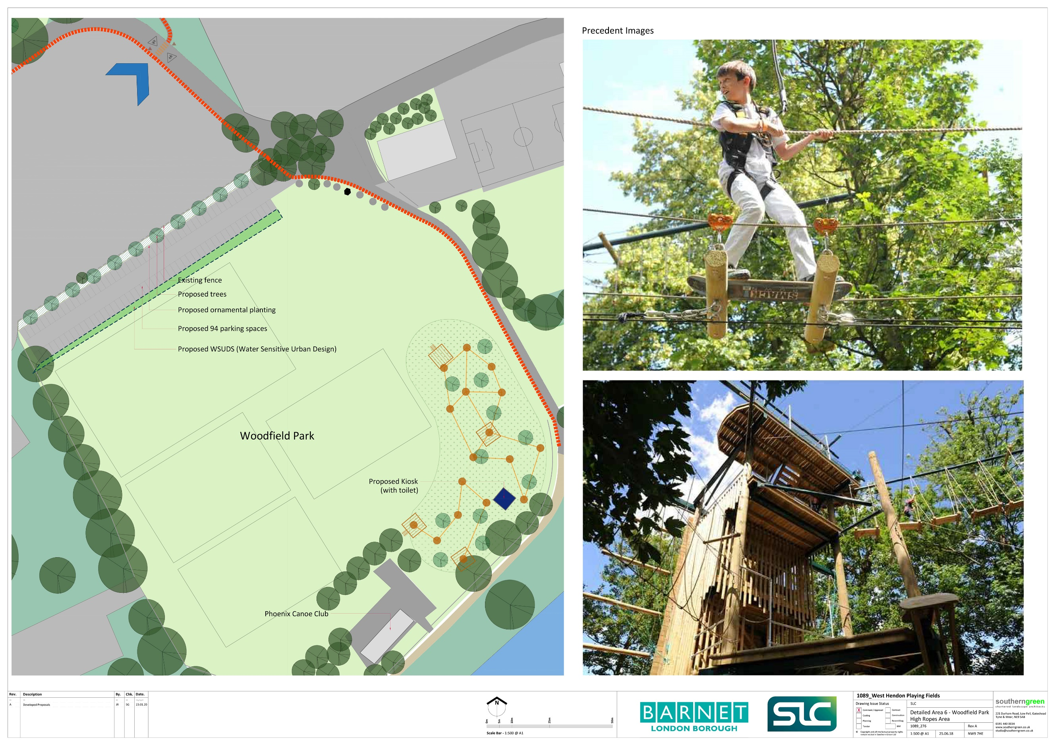

Business Case Amendments

In relocating the high ropes course to Woodfield Park, SLC has considered the potential impact upon the business case. Whilst it is assumed that there will be no impact upon the capital cost as a result of the relocation, it is likely to have some impact upon the revenue position.

In its previous location on West Hendon Playing Fields, it was assumed that it would be operated by an external leisure operator as part of the overall site offer to include the Community Sports Hub, adventure golf, ATPs etc. This would benefit from an existing management structure and sales team on the site and provide economies of scale and cross-selling opportunities as part of an integrated portfolio of facilities. With its location now being more remote from the Community Sports Hub, it is more likely to be managed on a standalone basis and may therefore attract additional management costs and potentially generate less income due to it being less ‘visible’ in terms of the wider offer on West Hendon Playing Fields.

The business plan previously developed by SLC projected an average annual surplus over a 10-year period of c.£87K for the high ropes facility. In view of the points above, SLC recommend that it would be sensible to assume a reduction in this surplus of c.£35K per annum as a result of the facility being relocated to Woodfield Park. Whilst this results in a reduced projected surplus of c.£52K for high ropes, it still provides a positive return on the Council’s investment.

conclusions

The conclusions arising from this final phase of the Masterplan and Feasibility Study for West Hendon Playing Fields and Associated Community Facilities are as follows:

1. The Council has successfully undertaken public consultation on the Final Draft Masterplan for West Hendon Playing Fields and engaged with over 900 local residents and stakeholders.
2. Feedback has been provided through a variety of channels, including an online questionnaire, public drop-in sessions, resident meetings, telephone and email.
3. The online questionnaire received 224 responses. 72% of respondents were supportive of the final draft masterplan and 21% were unsupportive. The most popular ranked facilities were improved pedestrian routes, improved grass pitches, café and toilets, improved cycle routes and woodland nature trail
4. The key areas of contention raised through the consultation were the proposed car park on Cool Oak Lane, the proposed location of the high ropes course, the artificial turf pitches and impact of these upon open space / biodiversity, the impact of proposed facilities on the SSSI/LNR and increased traffic and congestion.
5. In response to the consultation, SLC has explored the option of relocating the car park and high ropes course to Woodfield Park, supported by consultation with key stakeholders. This has proven to be a feasible option and is welcomed by interested parties including Princes Park FC and Phoenix Canoe Club.
6. Feedback from Planning and Highways Officers has revealed no significant issues and the proposed amendments in response to the public consultation were considered to be sensible.
7. The Final Draft Masterplan has subsequently been amended to include the relocation of the car park and high ropes course to Woodfield Park.
8. SLC recommend that the projected surplus for the relocated high ropes course is reduced by £35K. This is due to it being located more remotely from the proposed Community Sports Hub and other facilities on West Hendon Playing Fields and therefore not benefitting from being part of a more integrated offer.

APPENDIX 1: West Hendon Playing Fields Masterplan consultation report

A copy of the West Hendon Playing Fields Masterplan Consultation Report is provided as a separate document.

appendix 2: final draft masterplan

A copy of the Final Draft Masterplan for West Hendon Playing Fields is provided as a separate document.

