Barnet Council
Adult Social Care
Annual Complaints Report

2022-2023

Contents

1. Introduction

2. Adult social care Statutory Complaints Procedure

3. Accessing the complaints procedure

4. Overview

5. Compliments
6. Complaints

7. Learning from complaints

8. Local Government Ombudsman (LGSCO)

9. Responding to complaints and concerns about quality relating to external service providers
10. Demographic insight

- Introduction
Barnet Council’s adult social care service, part of the Communities, Adults and Health directorate, provides statutory social care services including individual care and support; safeguarding; information and advice; preventative services; assessments under the Mental Health Act (MHA 1983, amended 2007) and the Mental Capacity Act (MCA 2005). Social Care Direct acts as the front door for adult social care enquiries.
Comments, complaints and compliments are welcomed by the Service and are seen as a tool to help improve and develop services and practice. They provide the opportunity to learn from mistakes and to put things right for an individual when they have gone wrong.
Barnet Council is required, under statutory regulations, to report annually to the relevant Council Committee on adult social care complaints.
This report provides information about complaints for Barnet’s Adult Social Care Service for the period 1 April 2022 to 31 March 2023. The report considers complaints dealt with through both the Statutory Adult Social Care and Corporate Complaints Procedures where these relate to Adult Social Care.
- Adult Social Care Statutory Complaints Procedure
The Council is required to operate a separate Statutory Complaints and Representations procedure for adult social care, in accordance with the Local Authority Social Services and National Health Services Complaints (England) Regulations 2009 and the Local Authority Social Services and National Health Service Complaints (England) (Amendment) Regulations 2009. Any complaint which does not fall under these requirements is considered under the Council’s Corporate Complaints Procedure.
All complainants who have exhausted the Council’s Statutory and local complaints procedure retain the right to approach the Local Government and Social Care Ombudsman (LGSCO). The LGSCO is impartial and independent and act as the final stage for complaints about the Council, Social Care Providers, Care Homes and Home Care Agencies.
- Accessing the complaints procedure
The service continually seeks to encourage people who use social care and their carers, to provide feedback (positive or negative) on the services and customer care that they have received.
The process is publicised through the following means:
- Comments, Compliments and Complaints booklets are widely distributed to public offices in the Borough.
- The Easy Read version of the booklet ‘Comments, Compliments and Complaints’ is also widely distributed. This is aimed at people with Learning Disabilities and others who would find a simplified version easier to understand.
- Information about making a comment, compliment or complaint in relation to Adult Social Care is published on the council website www.barnet.gov.uk/comments-and-complaints-adult-social-care.
- Individual staff and managers, advise people who draw on social care support, their family, carers and relevant organisations of the procedures during their interactions with them, as appropriate.
- Managers are asked to feature compliments and complaints as a standing item in their team meetings and briefing sessions.
- Historic complaints reports are published on Open Barnet the council’s data portal, a valuable tool in pushing forward Barnet’s Transparency Agenda.
- Compliments are shared with staff and promoted internally through the staff newsletter, senior manager briefings and staff awards.
- Information about complaints and the learning from them is shared with the Management Team and with staff, to improve practice.

The council has commissioned Barnet Citizens’ Advice Bureau as the local lead provider for specialist information, advice and advocacy support. This ensures that the Council has a dedicated support service in place for people who require access to independent information, advice and advocacy. Staff are trained in accordance with the Care Act 2014 and staff understand their statutory duties in relation to advocacy.
- Overview
The following complaints and compliments were received into Adult Social Care in 2022/23 from individuals, carers and/or their representatives. To give these figures context, there were 6,348 new requests for services in 2022/23 (2,283 resulting from a hospital discharge). 5,445 people were receiving a long- term service. Of these, 4,186 were receiving a community service & 1,259 were receiving residential/nursing services.

- 128 compliments
- 78 statutory complaints
- 5 corporate complaints
- 12 Local Government Ombudsman enquiries

Of the 78 statutory complaints, 67 resulted in an outcome, 11 were withdrawn. Of the 67:
- 32 were not upheld
- 23 were upheld
- 12 were partially upheld

The main themes of complaints were:
- Quality - relates to the quality of service from care homes, home care agencies or care assessments
- Decision – disagreement with the outcome of a care assessment; or with the outcome of a financial assessment under the charging policy; or a decision made as a result of a statutory duty or national policy.
- Conduct – behaviour, communication or conduct of staff employed by care providers or by the council.

Common improvement themes were:
- Staff – formal reflection and training
- Procedures – updates and amendments to, or staff reiteration of procedures
- Provider - provider to review working practices, procedures, policies and contract compliance.

- Compliments
Compliments are just as useful as complaints in helping to improve service. By having people tell the Council when things are done well, the Council can make sure that it continues to recognise and build on its strengths. It is also important to recognise the excellent work that is being delivered and provides balance within the complaints annual report.

Many individuals who compliment staff and teams provide verbal feedback directly to individuals via face-to-face conversations or by phone; we do not reflect these in our annual figures. Formal written compliments received in the period were varied and ranged from individual messages of gratitude to team praise.
From 1 April 2022 to 31 March 2023, Adult Social Care received a total of 128 compliments. This is comparable to the 131 compliments received in 2021/22. Chart 1 provides an overview of compliments by service area:
Chart 1

The Mental Health Service figures include compliments received by the Network via its mental health enablement services. This service provides therapeutic group programmes and individual direct work for people experiencing mental health issues.

Examples of compliments received in 2022-2023

” I wanted to extend an enormous thank you to you for the quite outstanding care, support and attention you have shown to my mother and I over the past few weeks, day in day out. Answering calls on the mobile day and night and liaising with everybody in such a structured and caring approach, that I stand in awe. xxx you are one in a million - I am so glad to have met you and for your attention, kindness and help with everything so far.” Compliment regarding a member of Assessment and Prevention Services.

“I just felt that you should be aware of how terrific xxx is. Throughout my daughters review and assessment, he has been so helpful and clear and has always been open to both of us if we have any queries or concerns. He has been friendly and professional at all times, and his written assessment has clearly demonstrated that he has listened to both of us. xxx has always stressed and demonstrated by his approach that yyy’s needs are paramount. xxx has excelled in his role and we have nothing but praise for his calm and sensible approach.” Compliment regarding a member of Localities

“ xxx you are a stand out person showing compassion and kindness which made a huge difference to the quality of xxx’s life - sadly she recently passed away but she made it to 100 years.” Compliment regarding a member of Business Intelligence, Performance & Systems
“Thanks for everything you’ve done for Mum and I, xxx. My health was really impacted from time to time by everything around Mum’s finances and you took the stress away! Thanks again!" Compliment regarding a member of the Care Quality Service
“xxx has really made a positive change to my life and for my future, me and my family are so grateful for all the help she has given me, she is so savvy and very clever. I suffer with mental health and physical health problems and they are getting worse every day, BUT with all the help from (Barnet's angel's) they have made my life better happier and so much more. I will always remember xxx and yyy changed my life.” Compliment regarding members of the Mental Health Team
“Thank you so much for your caring approach. You are one of the shining lights in this system. With all my appreciation and gratitude for all your hard work and the dedication in what you do for the mental health community.” Compliment regarding a member of the Learning Disabilities Service
“We cannot thank you enough for your role in arranging the care package for Mum - it enabled her to be at home to the end, which was always her wish, and that made things much better for us. She was able to have family and friends visiting freely, so everyone came to see her in the last weeks which was lovely for everyone. So, thank you again for all that you did- you are someone who really made a difference in our lives.” Compliment regarding a member of the Hospitals & Health Team
“My social worker gave me a lot of support and care, she is very thoughtful and tactile, understandable, gives lots of hope and positive thoughts.” Compliment regarding a member of the Network

- Complaints
6.1 Overview of performance
From 1 April 2022 to 31 March 2023, Adult Social Care received a total of 83 complaints, 78 were considered under the statutory procedure and five were managed through the corporate complaints’ procedure.

It should also be noted that the service received 13 complaints which were resolved within 24 hours to the resident/person’s satisfaction and six potential complaints that were resolved outside of the formal procedure. In line with the statutory procedure, these were not formally recorded, but do highlight the services ambition to resolve immediate concerns (where guidance permits) as swiftly as possible.

Less than 1% of people who draw on social care support through the council (or someone acting on their behalf) raised a complaint in 2022-23. This percentage reduces further if we take into consideration all contacts into the service.

6.2 Complaints received by category.
Of the 78 Statutory Complaints received:
- 61 were considered as straightforward complaints
- 6 were considered as serious and/or complex complaints
- 11 were withdrawn

2022/23 witnessed a 14 percent reduction in the number of complaints that were recorded as serious and/or complex (high risk) and a slight increase (1%) in cases withdrawn.
6.3 Statutory Complaint outcomes
Of the 67 complaints with an outcome:
- 32 were not upheld
- 12 were partially upheld
- 23 were upheld

6.4 Statutory Complaints by Service Area
The table below provides a breakdown of statutory complaints figures for complaints with an outcome:
Service Area | 2021-22 | 2022-23 | No of complaints DOT | No. of cases upheld (2021-22) | No. of cases upheld (2022-23) | No. of cases partially upheld (2021-22) | No. of cases partially upheld (2022-23)
Localities (Older People & Physical Disabilities) | 16 | 11 | q | 0 (0%) | 6 (55%) | 4 (25%) | 1 (9%)
Assessment & Prevention | 5 | 4 | q | 2 (40%) | 2 (50%) | 0 (0%) | 0 (0%)
Integrated Learning Disabilities | 11 | 15 | p | 0 (0%) | 2 (13%) | 1 (9%) | 4 (27%)
Mental Health | 10 | 9 | q | 0 (0%) | 1 (11%) | 1 (10%) | 2 (22%)
Customer Financial Affairs | 8 | 8 | 1 | 2 (25%) | 3 (38%) | 1 (13%) | 0 (0%)
Integrated Care Quality | 4 | 7 | p | 2 (50%) | 2 (29%) | 0 (0%) | 1 (14%)
Hospitals & Health Partnerships | 7 | 13 | p | 1 (14%) | 7 (54%) | 4 (57%) | 4 (31%)
Total | 61 | 67 | p | 7 | 23 | 11 | 12

Complaints by Service Area:

Localities, Assessment and Prevention and the Mental Health service, all witnessed a reduction in the number of complaints received. The majority of complaints into the Mental Health Service were unsubstantiated and the service has one of the lowest uphold rates. Complaints received into the Assessment and Prevention service have decreased by 31 percent and were at their lowest in the last five-year period.

Complaints into Integrated Learning Disabilities, Integrated Care Quality and Hospitals & Health Partnerships all witnessed an increase in concerns raised.

Two of the three areas observing an increase in complaints all revolve around a particular theme/issue within the service.

The Hospitals and Health Partnership’s main areas of discontent, relate to changes in the national hospital discharge policy which came into effect in 2020. This policy change required that care home placements from acute hospitals, should be an interim placement to the first care home which can meet the need, with a full assessment to follow in a few weeks to establish long-term arrangements. This was a change from the previous system where long-term plans were made for a care home, whilst the person was still in hospital.

There was initial NHS funding to cover the cost of a care home placement for the first four weeks, until a full assessment could take place. This funding has ceased, and care home placements are now subject to financial assessment from the date of discharge. The two main reasons for these complaints are the person themselves not wishing to have to make a financial contribution to the interim placement; and the NHS not funding the placement through NHS Continuing Health Care funding (which covers all costs and is not subject to financial assessment). In addition, at times people drawing on care and support have been dissatisfied, that in times of high demand the Service may not always be able to complete new assessments within four weeks.

A new system of completing post-discharge reviews (where an assessment for Continuing Health Care funding is needed), has been implemented to give the Service more capacity to meet the high demand for post-discharge assessment. We are anticipating that this new system which encompasses a team of dedicated workers to oversee a person’s discharge into a care home and to complete NHS Continuing Health Care paperwork, assessments and post-discharge review, will improve future performance and ensure continuity of support for individuals.

Over 70 percent of cases received into the Integrated Care Quality Service related to residential or domiciliary care providers. As these relate to the service provided by an external organisation, these are passed to providers for initial investigation. If the outcome of their investigation is not satisfactory to the complainant or to the Care Quality Service, Adult Social Care may take further action.

In October 2022 the 18-25 Transitions team transferred into the adult social care Integrated Learning Disabilities Service, from Family Services. Six complaints in the year related to transition cases. These six complaints account for the services 36 percent increase in complaints. 40 percent of the overall complaints into the Integrated Learning Disabilities Service focused on discontentment with supported living and day care options. This is not a unique problem to Barnet and all local authorities are managing similar challenges; to provide care that meets both the specialised care needs of the individual in services that are close to family and friends. Addressing this can be complex, lengthy and involve legal consultation.

  - Complaints by category
The table below identifies complaints by subject and the investigation outcome.

 | Category | Upheld | Partially upheld | Not upheld
Decision (10) | Care Assessment - Assessment disagreement (including unhappy with decision) | 2 | 2 | 2
 | Care Home - General policy decision | 0 | 0 | 1
 | Finance - Assessment disagreement (including unhappy with decision) | 1 | 0 | 2
 | Total | 3 | 2 | 5
Conduct (11) | Staff Conduct - Conduct of council employed staff (attitude/ behaviour) | 2 | 2 | 6
 | Care Agency - Conduct of staff (attitude/behaviour) | 0 | 0 | 1
 | Total | 2 | 2 | 7
Quality (21) | Care Agency - Quality of service | 3 | 0 | 3
 | Care Assessment - Quality of service | 0 | 0 | 0
 | Care Home - Quality of service | 1 | 1 | 1
 | Care Assessment (process) | 0 | 1 | 0
 | Finance - Quality of service | 3 | 0 | 1
 | Hospitals – Discharge Process | 4 | 1 | 1
 | Care Assessment - Equipment provision/ Installation | 0 | 0 | 1
 | Total | 11 | 3 | 7
Timeliness & Delays (9) | Care Assessment - Assessment delay (including delay in making a decision) | 4 | 2 | 2
 | Care Home - Assessment delay (including delay in making a decision) | 1 | 0 | 0
 | Total | 5 | 2 | 2
Communication (7) | Care Assessment - Lack of communication | 1 | 1 | 3
 | Hospitals - Lack of communication | 1 | 0 | 0
 | Finance - Lack of communication | 0 | 0 | 1
 | Total | 2 | 1 | 4
Other (9) | Total | 0 | 2 | 7

Decision:

Ten complaints were received due to dissatisfaction with a decision reached by the Council or one of our providers. Five were either upheld or partially upheld. Four related to the outcome of a care assessment and one in relation to a financial/charging decision.

The five complaints that were not upheld, related to a statutory duty concerning either financial charging, national care legislation, regulations or policy, where the council or provider cannot influence the outcome. Where complainants are unhappy with the outcome of an assessment, the council can offer a reassessment or take into consideration changes of circumstance where relevant.

Conduct:

Eleven complaints were received in relation to staff conduct. Ten of these complaints were raised against council employed members of staff and one related to a staff member employed by a care agency. Four complaints in total were either upheld of partially upheld. Training, formal reflection and staff reminders are used to address complaints concerning the behaviour or conduct of staff. One of the upheld complaints resulted in a compliment for the team who acted swifty to resolve the issues once they were made aware of the problem.

Quality:

The largest number of complaints received were due to dissatisfaction regarding the quality of services provided directly from Barnet or its providers. Seven complaints regarding Barnet’s services were upheld and two were partially upheld. These were addressed through further training and a series of learning events, the implementation of additional auditing and procedural amendments. The upheld cases concerning care provider services were addressed through contract management procedures, with lessons learned fed into the work of the Integrated Care Quality team to shape the work it does with providers, thus improving the quality of provision across the social care market.

Delays & Timeliness:
This category relates to the time taken to conduct an assessment or provide a service. Waiting times for care assessments and financial reviews are the main cause of complaints relating to timeliness. Adult Social Care always seeks to avoid delays in assessing or reviewing clients and targets resources to ensure the most urgent cases and people with the highest levels of need are prioritised. However, any delay may understandably still be dissatisfying for members of the public whose assessments have not been prioritised.
Communication:
Seven complaints relating to poor communication were received in the period, three of these were upheld and addressed in formal reflection with the staff members concerned.

6.6 Timeliness of responses to statutory complaints within the internal 20
working day target
It is important to note that the Local Authority Social Services and National Health Service Complaints (England) Regulations 2009 Statutory Complaints guidance allows six months (commencing on the day on which the complaint was received) for the resolution of Social Care statutory complaints.

Adult Social Care are committed to help resolve as many complaints as speedily and efficiently as possible. The process is intended to be resolution focused and offer complainants the option of discussing their concerns in face-to-face meetings, family meetings and mediation where appropriate.

Our internal procedure is to maintain an internal target of 20 working days for straightforward complaints and 25 working days for more complex or serious complaints (or within an extended period of up to 65 working days)

It is also important to note that statutory complaints are managed through a single stage process. If the complainant is not satisfied with the initial response to their complaint, they can request further information or a further investigation which may prolong the overall outcome of a complaint. When a complaint was likely to exceed our initial target response date, we endeavoured to keep complainants informed of the case progress.

In 2022/23, all cases were closed within the statutory six-month period and 42 percent of cases were closed within our internal deadline. This is a two percent improvement on 2021/22 performance. We had anticipated a greater improvement in our performance in 2022/23, however, the a trial of a new IT corporate complaints system did not have the positive impact desired. The system requirements could not align with the Adult Social Care statutory complaints processes and the additional workload generated resulted in this aspiration not being met.

The following chart provides a breakdown of the 39 cases that were responded to out of time and the number of additional days the service required to fully resolve the concerns raised.

The cases in the 41+ days range involved multifaceted investigations, where the depth of the investigation and the time needed to investigate were proportionate to the seriousness of the complaint; examples include where legal advice on a case was required, changes in circumstances/ongoing developments, waiting for the outcome of a safeguarding enquiry, Local Government Social Care Ombudsman (LGSCO) and Care Quality Commission (CQC) investigations.

Co-ordination of responses with the NHS means that the Council may be obliged to work to the Statutory Social Care and National Health Service timescales, which allows a six-month timeframe for complaints to be investigated and responded to.

Complaints about providers being received through the complaints process, must be either signposted to the provider’s internal complaints process or managed through our internal procedures on behalf of the complainant. We do ask partner organisations to work within our timeframes, however this is a request and is not enforceable.

- Learning from Complaints
Learning from our complaints provides an opportunity to gain a deeper understanding of what is not working so well and ensures opportunities for improvement are realised and that future instances can be prevented, where possible.

In some cases, outcomes to complaints are case specific and there are no general learning points that would influence policy or procedure. Individual issues and staff/team specific learning is addressed through training, reflection, supervision and team meetings.

The table below categorises the learning themes and the number of lessons learnt that fell into each category. The table identifies the types of actions Adult Social Care’s management team and our providers and partners have taken to try and mitigate any further complaints of a similar nature. These are broad themes that enable us to monitor trends, however different actions will result from a theme.

Theme | No of lessons identified | Action
People  Issues relating to the behaviour or conduct of a member of staff | 31 | - Formal reflection  - Training  - Staff reminder
Policy  Review or amendment of a formal policy to reflect the need for change | 2 | - Reflection  - Audit  - Amend policy
Systems  Preventative updates /amendments to system/s, staff training on systems or applications | 4 | - Amend system  - Change working practice
Procedure  Changes to current procedures and working practice as a preventative measure | 18 | - Change working practice  - Amend procedure  - Cultural change
Provider  Work with a provider to review working practices, procedures, policies and contract compliance | 5 | - Report findings (to provider)  - Review contract  - Suspend provider

The below chart (chart 2) provides an overview of the actions taken as a result of learning from our complaints. In a number of cases there were several actions identified that were addressed to mitigate further complaints of a similar nature.

Chart 3 highlights the number of identified learnings by service area and chart 4 identifies the learning by complaint issue.

Chart 3

Chart 4

Examples of some of the learning from our complaint investigations:

Lesson Identified | Outcome
Several complaints identified communication issues in the current hospital discharge process in which staff from different teams complete the tasks of discharge, NHS Continuing Health Care (CHC) and post-discharge reviews. | A new system of completing post-discharge reviews has been implemented. A team of dedicated workers will supervise the person’s discharge into a care home, complete CHC paperwork, assessment and complete the post-discharge review to ensure continuity of support for people and for families, who will have a dedicated officer to communicate with them.
Social work staff were not always as specific and clear regarding funding of care after hospital discharge. | Discharge checklist used by social workers has been revised to include a very full section on funding and charging and workshops were provided in June 2023 to launch the tool.
- Local Government & Social Care Ombudsman

The Local Government and Social Care Ombudsman (LGSCO) is an external body that looks at complaints relating to councils and Adult Social Care providers. The LGSCO investigates matters where there is an alleged or apparent maladministration or service failure.

8.1 Complaints and enquiries dealt with by the LGSCO 2022/23

A complainant has the right to raise a complaint with the Local Government Ombudsman at any time. However, the Ombudsman will usually refer a complaint back to the council if it has not previously been considered under the council’s procedures. Such complaints are described as premature.

The table below (Table 1) presents the total number of new LGSCO enquiries received by Adult Social Care, for the period 1 April 2022 to 31 March 2023.This identifies that the number of enquiries reduced when compared to previous years (excluding 2020-21 when the LGSCO did not accept new complaints and stopped investigating existing cases between March and June 2020 to allow authorities to respond to the Covid-19 pandemic).

In 2022-23 the LGSCO changed their investigation processes, contributing towards an increase in the average uphold rate across all complaints. Adult Social Care’s uphold rate was 50%, this is lower than the councils overall average uphold rate of 78% and of other authorities overall uphold rate of 77%. However, our uphold rate has increase when compared to 2021-22.

 | 2018-2019 | 2019-2020 | 2020-2021 | 2021-2022 | 2022-2023
Enquiries | 20 | 19 | 12 | 17 | 12

Of the 12 enquiries received by the LGSCO in 2022/23:
- 6 cases were upheld - evidence of fault was found or we accepted fault early on
- 1 case was not upheld
- 5 cases were closed by the ombudsman after initial enquiries

In 100% of cases the Ombudsman were satisfied that Adult Social Care had successfully implemented their recommendations about what we needed to do to put things right.
- Responding to complaints and concerns about quality relating to external service providers
The Service is responsible for ensuring its contracted providers meet the quality and performance standards they have been set.

Adult Social Care requires all external providers of care and support services to operate a complaints procedure. For services regulated by the Care Quality Commission under the Care Standards Act 2000 (Homecare, Residential Care and Supported Living and Extra Care), this is a statutory requirement. For services that are not regulated, there is no statutory requirement but all new contracts for services commissioned by the council include a requirement to have a complaints procedure. This is also examined during the procurement process.

Where a person who used social care services or their representatives raises a concern about the quality of an external provider with the council, the Care Quality Service logs the matter and passes it to the provider to investigate, in line with their complaint’s procedure. If the outcome of their investigation is not satisfactory to the complainant or to the Care Quality Service, Adult Social Care may take further action, through the complaints process if this is the most appropriate route.
The Service takes complaints about providers very seriously, both to ensure individuals and their carers receive high quality services and to learn lessons and make improvements more widely where necessary.
If it is found that a provider regulated by the Care Quality Commission (CQC) does not meet the CQC’s fundamental standards, the Service will inform the CQC, acting primarily to ensure the safety of individuals and, once this is established, working with the provider to improve their standards.

- Monitoring Care Quality

The quality of care and support services is monitored by the Care Quality Service through a range of contract compliance mechanisms. These include:

- Quality Assurance visits, which include a review of complaints management by the provider.
- Quality alerts, which are written / telephone / electronic communications alerting us to a shortcoming in the delivery of a service.
- Working with the Care Quality Commission as appropriate when services do not meet the fundamental standards below which the provision of regulated activities and the care people receive must never fall.
- Responding to any other events, including safeguarding incidents which indicate that the provider is not fully complying with contractual requirements.

The table below provides a breakdown of concerns about quality that were passed to providers to investigate

 | 2020-2021 | 2021-2022 | 2022-2023
Complaints and quality alerts | 117 | 92 | 103  Care Homes & Extra Care- 9  Homecare-79  Supported Living- 15

For the Care Homes and Extra Care services these low numbers reflect that out of all services, care homes were the last to emerge from pandemic restrictions during 2022/23. Despite visiting by relatives and professionals resuming, it was reinstated slowly and with caution.

There are not any consistent themes for the nine quality alerts received, however specific areas that were mentioned more than once were incidents, staff training and dignity and respect.
Good practice and staff training are areas that we shall be reviewing at provider compliance visits.

The homecare concerns were mainly pertaining to missed/late calls and staff not always following the care and support plan. Across supported living there were no specific trends however the concerns reported were of a safeguarding nature.
We are currently reviewing the services via our contract quality assurance process using CM2000- visit monitoring (digital monitoring or arrival and departure times), PAMMS assessments (collaborative provider tool for quality assurance monitoring) and internal compliance tools.

- Complaints demographics

We have now linked our complaints data to Adult Social Care’s case management system, which has enabled us to capture demographic information. The demographic information provided below, is representative of the information held on our case management system against the individual drawing on care and support.

Overview of complaints by ward.
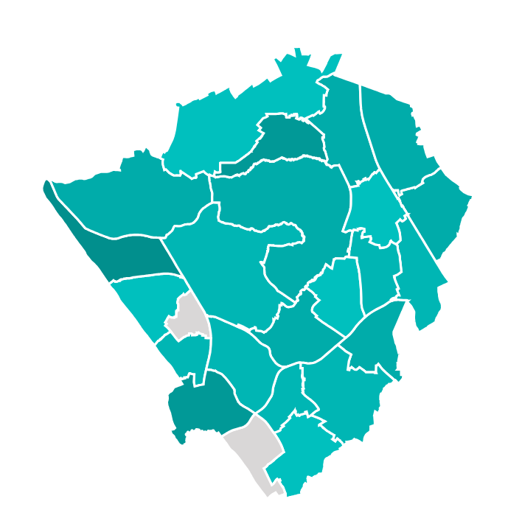
As this visual demonstrates complaints were received from wards across the borough. Darker shading on the map emphasises a higher number of complaints received. The highest proportion of complaints that we are unable to visualise were from individuals drawing on care and support provided out of borough (11 cases). The three wards with slightly higher complaint figures: Edgware, Underhill and West Hendon each received 2 complaints relating to the same individual within the period.

Ethnicity
The highest percentage of complaints (67%) were received from individuals who identify as white.
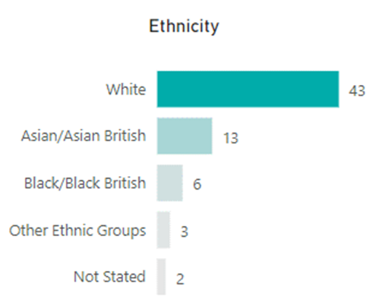
Age range of complainants

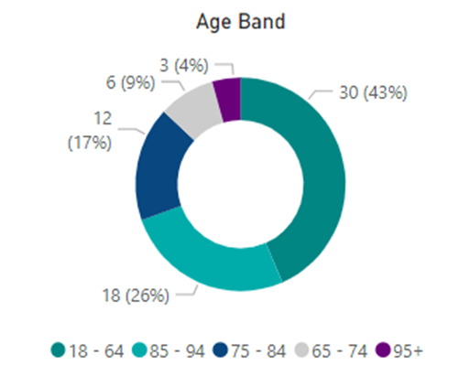
The majority of complaints related to people aged 65 and over (39 over 65 and 30 18-64). The population aged 65 and over in Barnet is around 58,000, of these over 3,300 clients are accessing long term support.

Gender

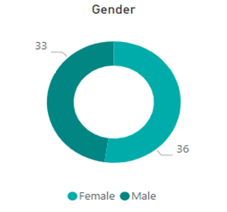
52% of complaints were about women who draw on care and support and 48% were about men.

Primary Support group

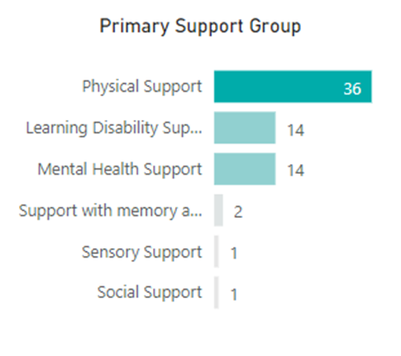
Complaint distribution from the six primary support groups align with the percentage (55.5%) of our service users who are accessing long term physical care and support. Physical support is the national reporting category which most often relates to care & support for older people, followed by working age adults with physical impairments.

