|  |
| --- |
|  |
| **Masterplan and Feasibility Study for Barnet and King George V Playing Fields - Addendum Report**  **Barnet Council**  January 20 |
|  |





**Contents**

1 introduction 2

1.1 Background 2

1.2 The Structure of our Report 2

2 summary of public consultation 3

2.1 Introduction 3

2.2 Stakeholder Engagement 3

2.3 Wider Public Engagement 3

2.4 Summary 4

3 amendments to masterplan following public consultation 6

3.1 Introduction 6

3.2 Meeting with Barnet Council 6

3.3 Further Stakeholder Engagement 6

3.4 Consultation with Planning / Highways 7

3.5 Masterplan Amendments 7

4 conclusions 10

5 APPENDIX 1: consultation report 11

6 appendix 2: final draft masterplan 12

introduction

Background

The Sport, Leisure and Culture Consultancy (SLC) was commissioned by Barnet Council in March 2018 to develop a masterplan and feasibility study for the development of a strategic sports hub with a wider leisure and community offer at Barnet and King George V Playing Fields.

The study was completed in February 2019 and the outputs provided to the Council through a report entitled Masterplan and Feasibility Study for Barnet and King George V Playing Fields.

The final draft masterplan was reviewed by the Council’s Environment Committee in March 2019 and approval given to undertake full public consultation on the masterplan. SLC was subsequently commissioned to support this process, collate the results and consider, through discussion with the Council’s Project Team, any required amendments to the masterplan arising from the public consultation.

This report provides an overview of this latest stage of the project and forms an Addendum to the main Masterplan and Feasibility Study report and should therefore be reviewed in conjunction with the main report.

The Structure of our Report

This report is structured to meet the requirements of the Council’s brief and to provide an accessible report setting out our core findings and key outputs.

Table 1: Report Structure

|  |  |  |
| --- | --- | --- |
| Section | | Key Content or Output |
| 2 | Summary of Public Consultation | Summary of feedback from consultation with key stakeholders and the general public. |
| 3 | Amendments to Masterplan Following Public Consultation | An overview of the amendments made to the final draft masterplan following the public consultation feedback. |
| 4 | Conclusions | Key conclusions arising from the consultation exercise. |

Supporting information is included in a series of Appendices.

summary of public consultation

Introduction

In Summer 2019, SLC supported the Council in undertaking a comprehensive public consultation on the final draft masterplan for Barnet and King George V Playing Fields. This was delivered through a combination of face-to-face meetings, email correspondence, telephone discussions, workshops, public drop-in sessions and an online questionnaire with key stakeholders and the general public.

The consultation process engaged with over 700 local residents and stakeholders during the 8-week period which demonstrates a good level of engagement.

A copy of SLC’s full report on the public consultation is provided in Appendix 1 and a summary of the key points and conclusions provided below.

Stakeholder Engagement

Key stakeholders were invited to provide feedback on the final draft masterplan, including current users / existing occupiers, local sports clubs, under-represented groups and local schools.

A summary of feedback is provided below:

* SLC attended a meeting of the **Dollis Valley Partnership Board**. Board members were generally positive about the proposed developments and felt that such facilities were needed in the local area, particularly for families and young people. Some members expressed concern regarding the Gaelic Football pitches and the overall effect of the proposals upon traffic and congestion in the area.
* SLC facilitated workshops with pupils (aged 11 – 15) from **Totteridge Academy** and pupils (aged 9 – 11) from **Underhill School**, who rarely utilised the park due to the lack of facilities. Positive feedback was received on the proposals, the most popular facilities being the skatepark, Clip and Climb, adventure play, café and multi-use games area (MUGA).
* Formal written feedback was received from the **Barnet Society** and **Theresa Villiers, MP for Chipping Barnet**. Both welcomed the approach to restore the playing fields and widen public access. However, the development was viewed as a ‘gross intrusion on the Green Belt’ and erosion of open space. Concern was raised mainly regarding the size of the Community Sports Hub, skatepark, car park and avenue of trees, as well as increased traffic in the area.
* Email correspondence was received from the Principal of the **Ark Academy**, who broadly supports the development, yet remains concerned about the proximity of the skatepark to the Academy and the disturbance it may cause due to their extended school day (4:30pm finish).

Wider Public Engagement

Local residents and wider general public were invited to provide feedback on the final draft masterplan through an online questionnaire, public drop-in sessions, email correspondence and social media.

The online questionnaire received 387 responses, 32% of which were from young people (under 25). 70% of respondents were supportive of the final draft masterplan (40% very supportive, 30% tend to support), whilst 19% were unsupportive (12% strongly oppose, 7% tend to oppose). The Council’s Facebook page on the masterplan received 91 ‘likes’.

70% of respondents noted that they would be more likely to visit Barnet and King George V Playing Fields if the masterplan was delivered and 57% said they would be more likely to be physically active.

The most popular ranked facilities were as follows:

* Café and toilets (83% support)
* Outdoor gym / trim trail (80% support)
* Improved pedestrian routes (79% support)
* Adventure play area (78% support)
* Toddler play area (76% support).

Over 68% of respondents were also supportive of improved cycle routes, multi-use games area (MUGA), multi-use activity space, Clip and Climb and football pitches.

The most strongly opposed facilities were the skatepark (24% unsupportive) and Gaelic Football pitches (23% unsupportive). The open comment boxes also highlighted key areas of concern as being the proposed skatepark, protecting the Green Belt and impact upon parking and traffic.

A total of five public drop-in sessions were hosted in prominent locations close to and in Barnet and King George V Playing Fields. These sessions were publicised to local residents through posters displayed in the playing fields and flyers which were distributed to neighbouring properties. The sessions provided an opportunity for local residents to view the masterplan up close, ask questions and provide feedback. The key themes arising from these sessions are listed below:

* Positive feedback received on extended cycle and pedestrian routes, re-instatement of the Dollis Brook bridge, outdoor gym / trim trail, café, re-providing the Rainbow Centre and overall provision for young people.
* Concerns were raised regarding the proposed skatepark in terms of its proximity to residents and the potential for noise disturbance and anti-social behaviour.
* Concerns over the loss of green, open space and protection of the Green Belt, particularly the avenue of trees and the scale of the car park and Community Sports Hub.
* Concerns over the impact on traffic movement and congestion in an already problematic area, particularly with the opening of the Ark Academy in September 2019.
* The success of the development will largely depend on future management arrangements, security presence and levels of maintenance.

## Summary

Overall, the consultation demonstrated clear support amongst users, stakeholders and the wider public for the principle of creating a more engaging space at Barnet and King George V Playing Fields, which improves opportunities for local people to be physically active and increases use of the playing fields.

The key areas of contention raised through the consultation include:

* The proposed location of the skatepark
* Ensuring a limited impact upon the Green Belt / open space
* The impact upon traffic, parking and congestion in the area.

amendments to masterplan following public consultation

Introduction

This section describes the steps undertaken by SLC and the Council in response to the public consultation and in addressing key areas of contention.

Meeting with Barnet Council

### A meeting with Barnet Council’s Project Team was held on 5th September 2019 to discuss the results of the public consultation and to decide on any potential amendments to the final draft masterplan.

### In response to the objections regarding the location of the proposed skatepark, in conjunction with concerns over the car park and erosion of greenspace, it was agreed to explore the feasibility of relocating these facilities. Extending the existing car park (south of Ark Academy playing fields) through acquisition of a strip of the land leased to Hadley Wood Sports Trust (HWST) was discussed as a viable opportunity. A small amount of parking, predominantly disabled parking, could also be provided to the west of the Community Sports Hub.

### This would result in a significantly reduced car parking footprint on the playing fields and would also provide a traffic-free and pedestrianised area immediately north of the Community Sports Hub. Keeping vehicular traffic within the existing car park area will provide a more accessible and pleasant approach to the Community Sports Hub and generally safer access around this central area. The amended parking also proposes a new access point between the car park and HWST pitches, including a new pathway through the site. This would provide HWST users with a safe and easy access route to the car park.

### This proposed amendment to the parking also provides an opportunity to relocate the skatepark west of the adventure play area (previously occupied by the car park). This moves the skatepark further away from residential properties and the Ark Academy, which would mitigate concerns regarding noise disturbance. Additional planting surrounding the skatepark would further act as a noise buffer. The proposed location would also provide enhanced supervision from the Community Sports Hub and mitigate concerns regarding anti-social behaviour.

### To explore this further, it was agreed that SLC should consult with HWST.

### In response to concerns raised about protecting the Green Belt and open space, it was agreed to remove the central avenue of trees, provide additional planting and landscaping throughout the masterplan (including a wildflower meadow behind the northern oak tree) and relocate the outdoor gym closer to the toddler play area. These amendments would be beneficial to retaining the openness of the site and enhancing the overall biodiversity.

Further Stakeholder Engagement

SLC undertook further stakeholder engagement in October 2019 to explore the feasibility of extending the existing car park. A telephone consultation was held with Hadley Wood Sports Trust (Table 1) and Southern Green Landscape Architects visited the area to undertake a high-level site analysis.

***Table 1: Consultation with Hadley Wood Sports Trust***

|  |  |
| --- | --- |
| **Name** | **Key Outcomes of Consultation** |
| **Aron Sharpe, Chairman, Hadley Wood Sports Trust** | An initial discussion with Hadley Wood Sports Trust highlighted that there is a key problem with parking both for their members and users of the playing fields. Initially, HWST were not in favour of extending the existing car park and losing part of their land which is utilised for runoff and spectator space. However, it was agreed that Southern Green could visit the area and complete a site survey in order to explore further the feasibility of this option.  The site survey confirmed that a small strip of HWST’s land would be required (c.6 metres) and sufficient space is available for the pitches to move southwards to retain the spectator space and runoff.  HWST are open to discussions with the Council to explore the feasibility of this option further and would welcome a meeting to discuss general parking in and around the site. |

Consultation with Planning / Highways

High-level feedback on the final draft masterplan for Barnet and King George V Playing Fields was provided by Barnet Council Planning Policy and Highways Officers at a meeting on 7th January 2020.

No significant issues were highlighted by the Planning Officer, but the planning application for Barnet / King George V will need to demonstrate any enhancements to the Green Belt and contribution to the ecological interest of the site, such as the Dollis Valley stream.

Similarly, no significant issues were identified by the Highways Officer at this stage, although the impact of further traffic as a result of development would need to be explored in detail through a transport and parking assessment as part of any future planning application.

Masterplan Amendments

Following the outcomes of this further consultation, the Council agreed for the following amendments to be made to the final draft masterplan:

Relocation of car parking through an extension to the existing car park immediately north of HWST and provision of disabled parking to the west of the Community Sports Hub.

Relocation of the skatepark to the area formerly occupied by the proposed car park.

Remove previously proposed footpath and avenue of trees on Barnet Playing Fields and provide increased green infrastructure to boundaries and wildflower planting.

Minor change to location of outdoor gym to bring it closer to the main hub area.

The Final Draft Masterplan is shown in Figure 1 and a full, high resolution version is provided in Appendix 2. A detailed area plan showing the relocated car park and skatepark is shown in Figure 2.

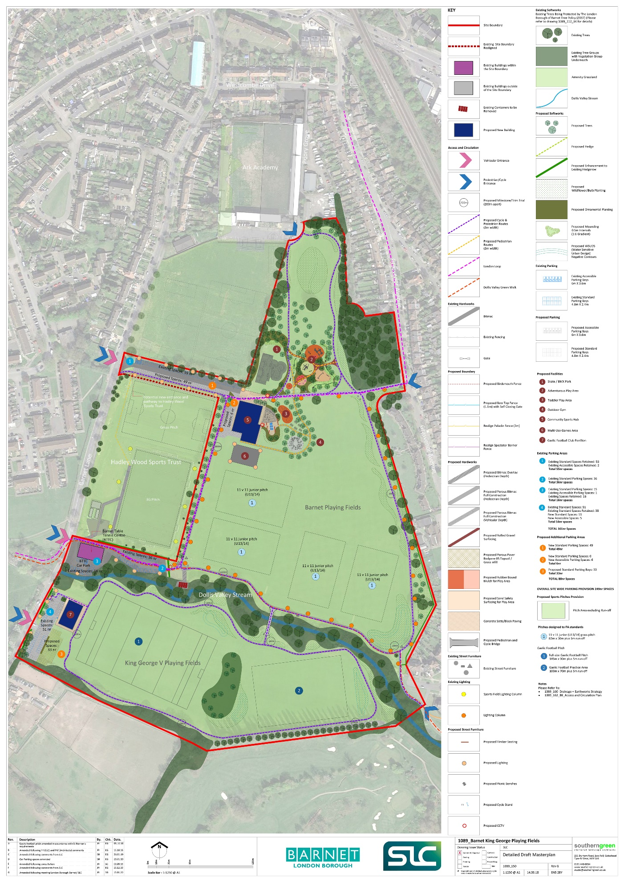***Figure 1: Final Draft Masterplan with Agreed Amendments***

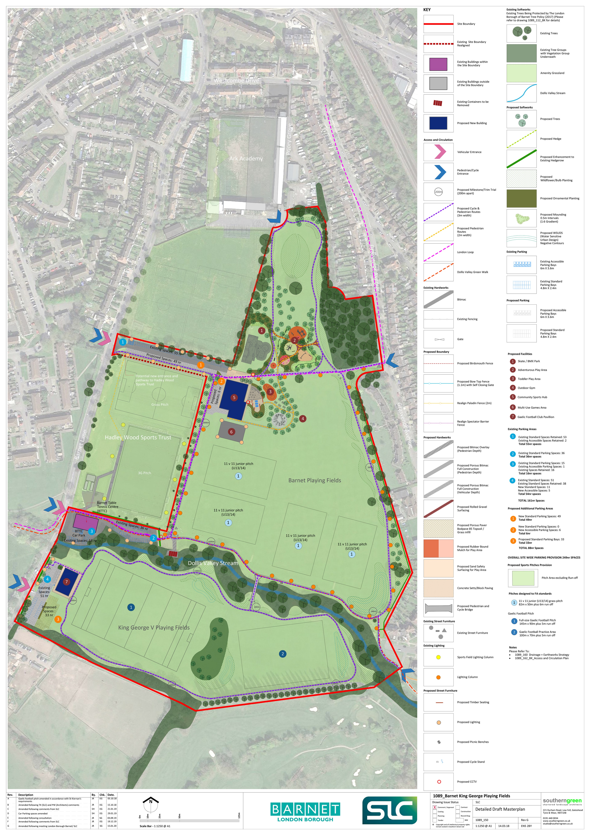Figure 2: Detailed Area Plan Showing Relocated Car Park and Skatepark

conclusions

The conclusions arising from this final phase of the Masterplan and Feasibility Study for Barnet and King George V Playing Fields are as follows:

1. The Council has successfully undertaken public consultation on the Final Draft Masterplan for Barnet and King George V Playing Fields and engaged with over 700 local residents and stakeholders.
2. Feedback has been provided through a variety of channels, including an online questionnaire, public drop-in sessions, resident meetings, telephone and email.
3. The online questionnaire received 387 responses. 70% of respondents were supportive of the final draft masterplan and 19% were unsupportive. The most popular ranked facilities were café and toilets, outdoor gym and trim trail, improved pedestrian routes, adventure play and toddler play areas.
4. The key areas of contention raised through the consultation were the location of the skatepark, the impact upon the Green Belt and open space and the impact upon traffic and parking.
5. In response to the consultation, SLC has explored the option of relocating the car park and skatepark, supported by consultation with key stakeholders. This has proven to be a feasible option and HWST are willing to discuss the option further with the Council.
6. Feedback from Planning and Highways Officers has revealed no significant issues and the proposed amendments in response to the public consultation were considered to be sensible.
7. The Final Draft Masterplan has subsequently been amended to include the relocation of the car park and skatepark. Further amendments include the removal of the central footpath and avenue of trees through Barnet Playing Fields and the inclusion of additional green infrastructure to boundaries and wildflower planting.

APPENDIX 1: consultation report

A copy of the Barnet and King George V Playing Fields Masterplan Consultation Report is provided as a separate document.

appendix 2: final draft masterplan

A copy of the Final Draft Masterplan for Barnet and King George V Playing Fields is provided as a separate document.

