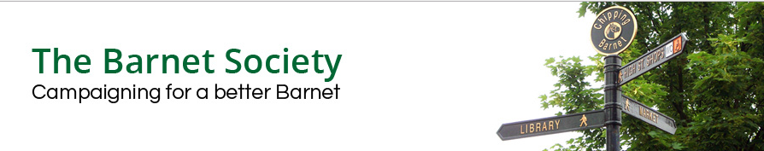

LB OF BARNET CONSULTATION:

Barnet Playing Fields & King George V Playing Fields –

Master Planning CONSULTATION: Draft Masterplan

RESPONSE BY THE BARNET SOCIETY

13 July 2019

INTRODUCTION

On 2 December 2018 the Barnet Society submitted a detailed response on the Council’s Phase 2 engagement on a draft masterplan. Receipt was acknowledged by Nicola Cross of the Environment Commissioning Group on 5 December, but no feedback was given.

The latest masterplan shows the skate/BMX park in a better position, but otherwise differs in only minor respects from the previous one. Most of our previous comments therefore still stand, but we take this opportunity to explain our reasoning in more detail.

RESPONSE TO LATEST MASTERPLAN

The Barnet Society welcomes the Council’s intention to restore Barnet & King George V Playing Fields, and to widen public access by providing a café with toilet facilities and play areas for children and their parents or carers.

However, we consider that the development proposed in the masterplan would be a gross intrusion into the Green Belt. It
- would be contrary to Council, Mayor of London and Government policies,
- would set a very bad precedent for future developments in the Green Belt, and
- requires a fundamental re-think of the building briefs and locations.

The present playing fields have historic, environmental and landscape value. Nonetheless, the Barnet Society could support the right kind of building, the right landscape features, in the right place, and to high standards of design and environmental quality. But the published scheme does not so far demonstrate any of these. Nor is its financial viability clear.

Green Belt

Our basic objection to the current proposals is that the playing fields are within the Green Belt, which Barnet Council, the Mayor of London and the Government are all committed not to build on – and which the Barnet Society was founded to protect.

The National Planning Policy Framework (February 2019) allows development of the Green Belt only in very special circumstances. Clause 145 states:

A local planning authority should regard the construction of new buildings as inappropriate in the Green Belt.

It is true that exceptions permitted under sub-clause (b) include:

the provision of appropriate facilities (in connection with the existing use of land or a change of use) for outdoor sport, outdoor recreation…

but the NPPF lays down a crucial condition:

…as long as the facilities preserve the openness of the Green Belt...

Barnet Council’s own commitment to the Green Belt is unambiguously set out in Policy CS7 of its Local Plan (September 2012):

We will create a greener Barnet by: protecting open spaces, including Green Belt and Metropolitan Open Land…

Its own Planning Committee recently provided a highly relevant precedent. On 28 May 2019, an application (19/1866/FUL) for 230 square metres of stables on Mays Lane in the Green Belt was refused, in part on the grounds that:

The proposed development by reason of its location within the Green Belt would represent an inappropriate form of development which would harm the openness of and intrude into the rural character of the Green Belt. No case for very special circumstances has been demonstrated to outweigh the harm caused to the Green Belt by reason of inappropriateness. The proposed development would have an unacceptable impact on the aims and purpose of the Green Belt, contrary to Policies CS NPPF, CS1, CS5 and CS7 of the Local Plan Core Strategy (September 2012), Policy DM01 and DM15 of the Local Plan Development Management Policies DPD (September 2012), Policy 7.16 of The London Plan 2016 and paragraphs 143 and 145 of the National Planning Policy Framework 2019.

The building proposed on Barnet Playing Fields – five times the area of the stables and twice as tall – could hardly be more damaging to their openness, and would be a flagrant breach of the Council’s own policy.

Wrong kind of building

The demand for a new sports or community hub is unproven. Apart from public responses to the earlier consultations, little dialogue seems to have taken place with any stakeholders except for the Rainbow Centre and a couple of neighbouring schools and (in the case of the K George V Fields) the Gaelic Football Club.

We acknowledge that the Council has a duty to rehouse the Rainbow Centre, but the scale of the proposed accommodation is way beyond the latter’s present premises.

The proposed hub would not be a sweet little pavilion in the park. Its floor plan totals almost 1,200 square metres – nearly as large as a one-form entry primary school. The building alone would cost several million pounds.

To be commercially viable, its multi-purpose activity hall would need to meet Sport England’s badminton standards (for lettings or competitions), which require an internal height of at least 7.5 metres (25ft). A challenging climbing wall would need to be of similar height. The building would therefore be highly visible from all parts of the playing fields.

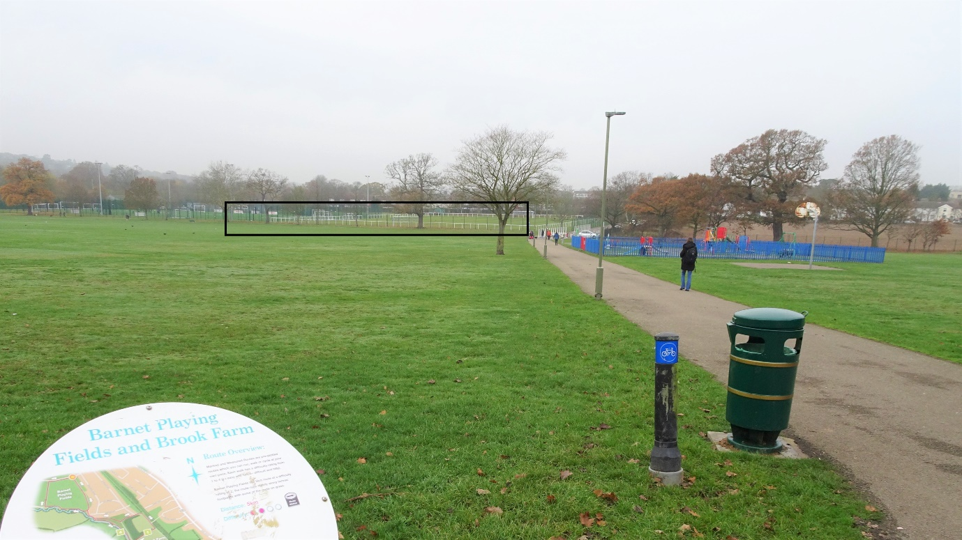
Barnet Playing Fields – The box indicates the probable bulk of the proposed building

No hard evidence is supplied of community demand for such an ambitious project. Since only the outdoor play would be free to use (according to the FAQ), public interest would be conditional on favourable pricing.

The duplication of Ark Pioneer Academy facilities close by is particularly frustrating. Ark was given planning permission on condition that its outdoor and indoor sports, music, drama and dance facilities would be available to the community. It should be held to its word.

Wrong landscape features

Improving the existing grass pitches would be welcome, and the K George V Playing Fields could be revitalised by Gaelic Football with a new pavilion on the footprint of its burnt-out predecessor. We are very concerned, though, to find that the Gaelic Football pitch would have a new fence around it, spoiling the lovely long views and confining walkers, joggers and cyclists within an unnatural and unattractive peripheral corridor.

The proposed new Dollis footbridge and perimeter trail would certainly encourage more use of this site. A better position for the bridge, however, might be at the S-E corner of Barnet Playing Fields, where it would be more convenient for the many travellers from Whetstone. By directly linking the existing Dollis Valley cycleway to Barnet Lane, it would also neatly siphon off most cyclists from the footpaths of Barnet Playing Fields.

Given the significant projected increase in residents in the neighbourhood in the next few years, the corresponding increase in walking, runners and cyclists will put extra pressure on playing field paths. Some separation of cyclists is desirable, but not shown on plan.

Unnamed mauve shapes are shown parallel to Grasvenor Avenue and elsewhere. These need explanation. If they are mounds, they would obstruct residents’ view of Barnet Playing Fields.

Enrichment of Barnet Playing Fields would be good for plant, wildlife and visual variety, and make them more resilient against climate change. For example, hedgerows could be thickened and groups of trees planted to form wildlife corridors between the existing Dollis Brook and Grasvenor Avenue copses; but those don’t appear to be proposed.

What is proposed is an new formal N-S avenue of trees, roughly parallel to the row that already partially screens the Hadley Wood Trust’s multi-use games area (MUGA). Instead of further eroding the openness of the playing fields, a more effective solution might be to align the footbridge with the existing path, and thicken up the latter’s row of trees to mitigate the overbearing impact of the high fence and the glare of floodlights.

What will not enhance Barnet Playing Fields’ natural qualities is a concrete skate/BMX park, or yet more artificial surfaces, high fencing and floodlights – but all these are being proposed. Do we need another MUGA, when surely the existing Ark and Hadley Wood Trust’s all-weather pitches will be ample?

Finally, are 66 extra parking places needed on Barnet Playing Fields? They would disincentive walking and cycling, and are bound to exacerbate existing traffic congestion in Barnet Lane.

Wrong place

If a business case can be made for these facilities, though, are they in the right place?

Undoubtedly the Rainbow Centre would benefit from a new home – but does it make sense in the middle of Barnet Playing Fields? And is that the place to locate the new café and sports facilities, far from public transport? It is also perverse to bring 66 cars into the centre of this green space.

It is not simply the great extent of the new building and artificial surfaces that would impact on the openness of the green space, it is their accompanying road lighting, floodlights and high fencing – all right in the heart of Barnet Playing Fields. The visual impact would be bad enough by daylight; at night, when the lights are on, it would be even worse.

The new surfaces, fences and lights would also be detrimental to wildlife such as bats and hedgehogs, effectively restricting it to the narrow strip of woodland along the Dollis Brook and hastening species extinction.

A new building and car park would be so much simpler and cheaper to provide at the edge of the site, where they could be easily accessed and serviced (and more cheaply connected to main services and drains). Better still, they wouldn’t dominate every view of the parkland.

The proposals would be easier to judge if other possible locations had been studied (as is normally done with this sort of project). For some reason, the former cricket pavilion (an obvious candidate for reuse) was excluded from this study. But why haven’t other sites been considered?

For example, couldn’t the hub located alongside Barnet Table Tennis Centre, and the opportunity taken to tidy up the most neglected part of the present fields? If the proposed footbridge were moved to connect this and the Gaelic Football pavilion and car park, a far more integrated and acceptable development would be possible. Locating the new building complex directly off Barnet Lane would considerably reduce the cost of new utilities and access roads. The Gaelic footballers could share their car park with community/sports hub users. The Table Tennis Centre could benefit from the cost savings of sharing indoor and outdoor space. And the whole development would be confined to a less obtrusive corner of the playing fields and screened by existing and new planting.

Standard of design and environmental quality

Any building or landscape development on these valuable Green Belt sites must be an exemplar of design if it is to be acceptable. It is too early to comment on the buildings’ or landscapes’ design quality, but we would expect them to meet Mayor of London, CABE or equivalent standards, as well as BREEAM ‘excellent’ rating.

The ecological assessment of all the playing fields and their fringes should be made available to the public. Whatever finally emerges must minimise use of energy and water, and harm to existing landscapes and wildlife.

Financially sustainability

A robust business case for the proposals must be demonstrated. The capital and running costs would be considerable. Barnet has made clear in its Parks & Open Spaces Strategy (and elsewhere) that no Council funding can be expected for such projects, so where will they be found?

To the west and south along the Dollis valley, and elsewhere in Barnet such as Tudor Park, sports and community facilities have been built in the past with the best intentions, but have been under-used and left to decay. It would be stupid and irresponsible not to learn those lessons. A rethink is essential.

